**3rd Severn Estuary Forum**

**Friday 19th September 2008**

***‘A Severn Estuary Double Bill’***

***Renewable Energy and Secrets of the Severn***

***A conference to discuss issues affecting the future of the Severn Estuary***

***Hosted by the Severn Estuary Partnership (SEP)***

**Conference Programme - The Paget Rooms, Penarth**

***09:00 Registration & Coffee***

**09:30 Welcome** A welcome note from Jane Davidson AM - *Minister for Environment, Sustainability and Housing.*

**09:45 Renewable Energy and Energy Policy for the Severn Estuary**

Chair: George Ashworth, *SEP Management Group Chair*

‘Tidal Power: Management & Mechanisms’ - Gary Shanahan, *BERR*

‘Tidal Power: The Options’ - Peter Kydd, *Parsons Brinckerhoff*

‘Flooding: The Forecast’ – Nick Lyness, *Environment Agency*

**Panel of Speakers & Debate**

***10:45 Coffee & Informal Networking***

**11:00 Secrets of the Severn**

Chair: Peter Tyzack, *SEP Chair*

‘A Modern Port’ – John Chaplin, *Bristol Port Company*

‘Tale of a Tunnel’– Geoff Ballinger, *BBC Wales*

‘Wild Spaces and Places’ – Dave Paynter, *WWT Slimbridge*

‘A Blast from the Past’– Peter Kavanagh, *Severn Estuary Fisherman's Association*

***13:00-19:00 Afternoon Cruise aboard the M.V. Balmoral***

**13:00 Display from Penarth RNLI as the M.V. Balmoral departs Penarth Pier**

***13:30 Luncheon and Informal Networking***

14:15 Opportunity to board M.V. Balmoral from Clevedon Pier

**14:30 Series of Talks and Displays on the Secrets of the Severn**

‘Saving Lives’ – Mervyn Fleming, *Severn Area Rescue Association*

‘Out and About by Boat’ - Don Sutherland, *Royal Yachting Association*

‘Stern Back Time’ - Andrew Wiltshire, *Cardiff University*

‘An Angle on Angling’ - Don Metcalfe, *Bristol Channel Federation of Sea Anglers*

‘Current Conditions’ - Nick Rodgers, *Cardiff University*

*‘*Steep Holm’ *–* Joan & Stan Rendell*, Steep Holm-Kenneth Allsop Memorial Trust*

‘Flat Holm’ – Glyn Jones, *Cardiff Harbour Authority*

‘Excavating the Facts’ – Toby Catchpole, Gloucestershire County Council

17:45 Return to Clevedon Pier

***18:00 Informal Networking on return cruise to Penarth***

***19:00 Return to Penarth Pier***

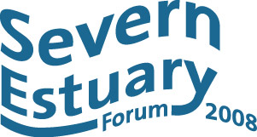

* **Renewable energy**: threats and opportunities for the Severn
* **Flood risk management**: finding ways forward

Presentations will be combined with workshops and discussion sessions. The Forum brings together decision-makers from local authorities, statutory agencies and industry with representatives of non-governmental organisations, clubs, societies and user/interest groups, from Gloucester to Minehead in England & Nash Point in Wales.

*Departing from Clevedon Pier (& Penarth) following the conference*

**Reception with speakers and workshops on a late afternoon/evening cruise on** *The Waverley,* **the oldest ocean going paddle steamer *in the world.***

A flavour of the festival and wide range of estuary interests will be available on board!

* ASERA Advisory Group
* COREPOINT Research Strategy & Forum
* Les Esturiales (and/or Fri 9th)

**To register a place at the 1st Severn Estuary Forum, please contact us:**

**Email:** [**severn@cardiff.ac.uk**](mailto:severn@cardiff.ac.uk)

**Tel: 029 20 874713**

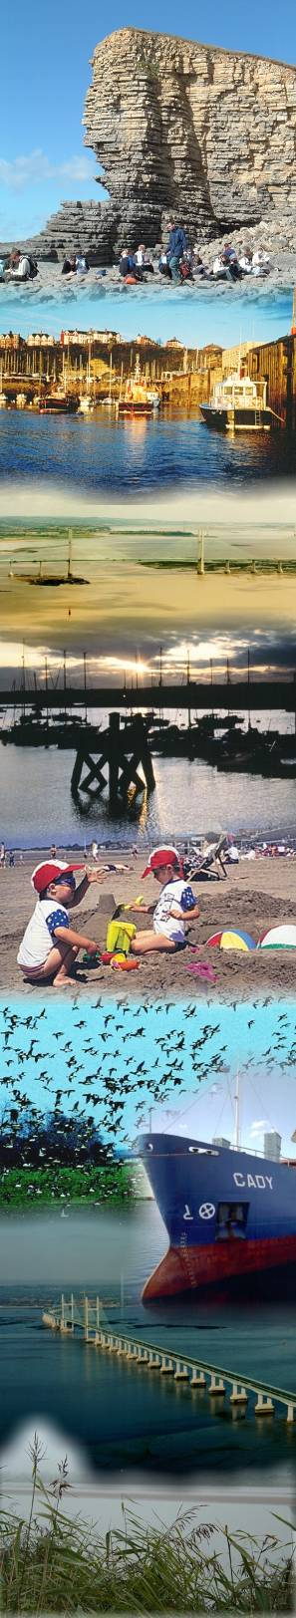

SEPlogo

***Working together for the future of our estuary***

**Severn Estuary Partnership**

c/o School of Earth, Ocean and Planetary Sciences,

Main Building, Park Place,

Cardiff University, Cardiff CF10 3YE

Tel: 02920 874713 / 07973 176961

[www.severnestuarypartnership.org.uk](http://www.severnestuarypartnership.org.uk)

Email: [severn@cardiff.ac.uk](mailto:severn@cf.ac.uk)

